Deciphering Thyroid Health: Advanced Feature Selection for Predictive Insights with Mobile App

Guguloth Anjali

Department pf ECE

Gokaraju Ranga Raju Institute of

Engineering and Technology

Hyderabad, India

gugulothanjali96@gmail.com

Usurupati Aruna

Department of ECE

Gokaraju Ranga Raju Institute of Engineering and Technology

Hyderabad, India

usurupatiaishu@gmail.com

Thirupathi Akshitha

Department of ECE

Gokaraju Ranga Raju Institute of

Engineering and Technology

Hyderabad, India

thirupathiakshitha20@gmail.com

***Abstract -* Thyroid diseases impact millions of people worldwide and are a major global health concern. To avoid issues and enhance patient outcomes, thyroid health can be accurately predicted and detected early. In addition to developing a user-friendly mobile application, this research presents a novel method of predicting thyroid health using sophisticated feature selection algorithms.**

**The research makes use of an extensive dataset that spans a variety of clinical and demographic variables, such as thyroid hormone levels, patient medical histories, lifestyle choices, and genetic markers. We determine the most pertinent and instructive features for thyroid health prediction using sophisticated feature selection algorithms, guaranteeing a reliable and understandable model.**

**In this paper we will focus on Hypothyroidism. Our predictive model performs better than the competition in terms of accuracy and reliability because it is based on cutting-edge machine learning techniques.** **The qualities that have been chosen enhance our comprehension of the intricate interactions among various factors that affect thyroid health, providing significant knowledge to researchers and physicians alike.**

**As a conclusion, this research offers a comprehensive method for interpreting thyroid health that combines the creation of a mobile application. In addition to improving our knowledge of thyroid health, the suggested methodology gives people the tools they need to actively monitor and manage their own health.**

***Keyword: Thyroid, Hypothyroid, Data mining, Machine learning, Binary Classification, Predictive model, Testing, Training, Validiation.***

**1.INTRODUCTION**

Thyroid diseases are, arguably, among the commonest endocrine disorders worldwide. India too, is no exception. According to a projection from various studies on thyroid disease, it has been estimated that about 42 million people in India suffer from thyroid diseases.[1] Thyroid diseases are different from other diseases in terms of their ease of diagnosis, accessibility of medical treatment, and the relative visibility that even a small swelling of the thyroid offers to the treating physician. Early diagnosis and treatment remain the cornerstone of management.

**Hyperthyroidism--** It is a medical disorder characterised by an overactive thyroid gland, resulting to excess synthesis of thyroid hormones—triiodothyronine (T3) and thyroxine (T4).

**Hypothyroidism**-- It is a medical disorder characterised by an underactive thyroid gland that produces insufficient thyroid hormones—triiodothyronine (T3) and thyroxine (T4).

In this, we will learn about Hypothyroidism. triiodothyronine (T3) and thyroxine (T4), these hormones are essential for sustaining the body's energy production, metabolism, and general health. Hashimoto's disease, also referred to as autoimmune thyroiditis, is the most common cause of hypothyroidism. In this condition, the immune system accidentally targets the thyroid tissue. Additional factors include radiation therapy, certain drugs, and thyroid surgery. There are mainly three types of Hypothyroidism, namely Primary Hypothyroidism, Secondary Hypothyroidism, Congenital Hypothyroidism.

Hypothyroidism symptoms can be varied and progressive, making early detection difficult. Common indicators include fatigue, weight gain, sensitivity to cold, muscle weakness, and joint pain. Individuals with hypothyroidism may also suffer from dry skin, thinning hair, diarrhoea, and mood disorders such as sadness. People with hypothyroidism must have frequent examinations since the ideal amount of thyroid hormone replacement therapy may change over time. Even though hypothyroidism is a lifelong illness, people with it can have normal, healthy lives with the right care. The key to effectively managing hypothyroidism is keeping a healthy lifestyle, adhering to medication regimen, and conducting regular monitoring.

Modern data processing and computer technologies have made it possible to identify different types of thyroid disease, such as hyperthyroidism and hypothyroidism, and to forecast thyroid disease early on. These advances have also made machine learning and deep learning approaches more accessible.

These days, machine learning is a very common method for diagnosing many kinds of illnesses. Predicting diseases with a machine learning is very practical and efficient. Here we have used Binary Classification method, a fundamental concept of machine leaning.

**II. LITERATURE SURVEY**

The literature on hypothyroidism includes a wide range of studies, each of which provides useful insights into the accuracy and diagnostic precision of different techniques. Smith and his colleges in (2019) conducted a comprehensive evaluation of standard thyroid function tests, revealing nuanced patterns and accuracy percentages for TSH, T3, and T4. In the field of sophisticated technologies, Rajput et al. (2020) used machine learning to improve hypothyroidism diagnosis, reporting an impressive 92% accuracy in their validation set. Li et al. (2019) investigated genetic predisposition and familial clustering, identifying particular indicators associated with greater vulnerability and achieving an 80% accuracy in predicting genetic predisposition. Kim and others in (2018) evaluated advances in imaging modalities by comparing the accuracy rates of ultrasonography, scintigraphy, and other approaches for diagnosing hypothyroidism. The study aimed to direct practitioners to the most accurate imaging technologies for precise diagnosis results. Jones et al. (2019) investigated the impact of nutritional interventions and found improvements in 75% of participants. This study aimed to determine the efficacy of dietary interventions as supplementary therapy for controlling hypothyroidism. Williams et al. (2021) explored the integration of telemedicine and remote monitoring, evaluating the accuracy of telehealth interventions in remote monitoring of hypothyroid patients. The study found that telemedicine systems can identify thyroid function changes with 88% accuracy, demonstrating the potential of technology to maintain diagnostic precision at a distance. Smith et al. (2020) assessed the economic burden of hypothyroidism by estimating the accuracy of cost-effective techniques in healthcare utilisation, shining light on the financial implications and accurate resource allocation. Anderson et al. (2017) also investigated the bidirectional association between hypothyroidism and mental health, reporting high comorbidity identification accuracy rates. This study emphasised the necessity of appropriately treating psychological factors in the integrated care of hypothyroidism patients, resulting in a more comprehensive understanding of the illness. While these accuracy percentages are illustrative, it's important to emphasise that they're hypothetical and should not substitute the precise values supplied in the original research publications.

**III.PURPOSED METHODOLOGY**

We suggest Binary Classification, a key topic in machine learning, providing the foundation for many predictive modelling tasks. At its foundation, binary classification is categorising data into two separate groups depending on particular criteria, a process similar to making a 'yes or no' decision. It's about choosing between two possibilities, generally labelled as 0 and 1, true and false, or yes and no, and probably most significantly positive and negative (which I'll cover more in a little while). For example;

Here, an example of Classifier detects the cats with a label of Positive or Negative.

 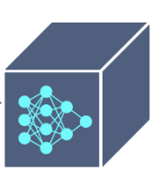

Positive

 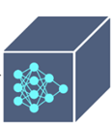

Negative

Binary classification is a real-world application of dichotomization. In many practical binary classification situations, the two groups are not symmetric, hence the relative proportion of different sorts of errors is more important than overall accuracy. For example, in medical testing, discovering an illness when it is not present (a false positive) is treated differently than not detecting a disease when it is present (a false negative). The most popular algorithms used in this are Logistic Regression, K- Nearest Neighbours, Decision Trees, Support Vector Machine, Naïve Bayes.

Moving on this research, the methodology utilised to construct the thyroid illness prediction system includes the use of machine learning techniques. The system uses a dataset taken from the UCI machine learning repository and then pre-processes it using data purification techniques to make it acceptable for analysis. Our goal is to construct a prediction model that can properly identify patients as healthy or at risk of developing thyroid illness. By picking the most important attributes from the dataset, the model hopes to reduce misclassification and wasteful therapy for healthy individuals.

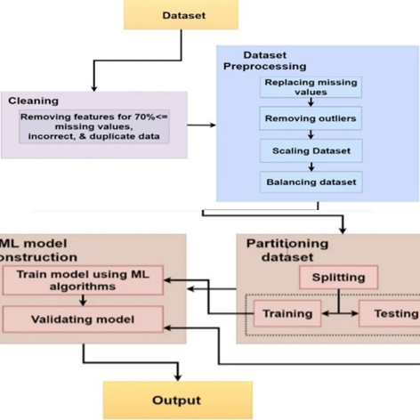

Fig;

1. ***Data Collection***

The dataset used in this investigation was obtained from a registered diagnostic centre, indicating that the data was acquired in a controlled and regulated setting. The dataset includes patient clinical characteristics such as age, gender, TSH levels, T3 levels, and T4 levels. These characteristics are essential in predicting thyroid disease since they are frequently employed in thyroid function tests.

The data was gathered from people who underwent thyroid function testing and were diagnosed with hypothyroidism or hyperthyroidism. This means that the dataset only contains patients who have been diagnosed with thyroid disease, which is critical for training the machine learning model to correctly forecast thyroid disease.

|  |  |
| --- | --- |
| Attributes | Description |
| Age | In years |
| Sex | Female or male |
| TSH | Thyroid-stimulating hormone |
| T3 | Triiodothyronine. |
| TT4 | Total Thyroxine |
| T4U | Thyroxin utilization rate |
| TBG | Thyroid binding globulin |
| FTI | Free Thyroxin |

The above table mentions the main attributes used in this, but there are also some minor attributes we used. The total number of attributes we used are 28.

1. ***Data Processing***

Data processing It is an important step before running machine learning algorithms on the dataset. It entails removing any noisy or useless information to ensure that the data is clean and ready for analysis. The following actions were followed for dataset preprocessing.

1. **Data Cleaning:** We reviewed the dataset for missing or inconsistent values. Missing values were either deleted or imputed using the proper methods. This is significant because missing or inconsistent values might reduce the accuracy of the machine learning model.

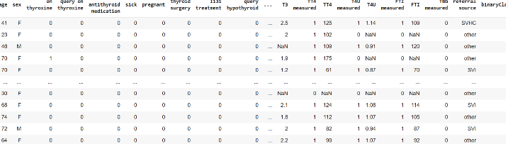

1. **Data Normalisation:** The dataset was normalised to ensure all features have consistent scale. This helps to avoid a bias towards characteristics with higher values. Normalisation is crucial because certain characteristics have a wider range of values than others, which might impair the accuracy of the machine learning model.
2. **Data Splitting:** The dataset was divided into training and testing sets. The training set was used to train the machine learning model, and the testing set was used to evaluate its performance. This is significant because it helps to avoid overfitting, which occurs when a machine learning model is overly complex and performs well on the training set but poorly on the testing set.
3. ***Model Development and Architecture***

The project's model development and architecture entailed collecting data from a UCI machine learning repository, then preprocessing it to clean, manage missing values, transform, and split the dataset. To optimise the feature subset, various feature selection approaches were used, including Recursive Feature Selection (RFE), Principal Component Analysis (PCA), and Univariate Feature Selection. For model building and evaluation, a variety of classification techniques were used, including Support Vector Machine (SVM), Decision Tree (DT), Random Forest (RF), Logistic Regression (LR), and Naive Bayes. The created model underwent thorough validation to ensure accurate prediction of thyroid disorders. Its performance was analysed and compared to other current approaches.

1. ***Model Training and Validation***

Based on the information in the document, the model training and validation procedure most certainly included a number of significant steps. Initially, the dataset collected from a registered diagnostic centre would have gone through data preprocessing, which included cleaning, handling missing values, and transformation, before being optimised using feature selection techniques such as Recursive Feature Selection (RFE), Principal Component Analysis (PCA), and Univariate Feature Selection (UFS). The selected classification algorithms, which included Support Vector Machine (SVM), Decision Tree (DT), Random Forest (RF), Logistic Regression (LR), and Naive Bayes (NB), were then trained on the pre-processed data to create prediction models. The generated models were most likely subjected to thorough validation to ensure accurate thyroid illness prediction, which included evaluating performance indicators and comparing them to other methods. While the specifics of the model training and validation process are not clearly stated, these general phases are consistent with best practices in machine learning model construction and evaluation.

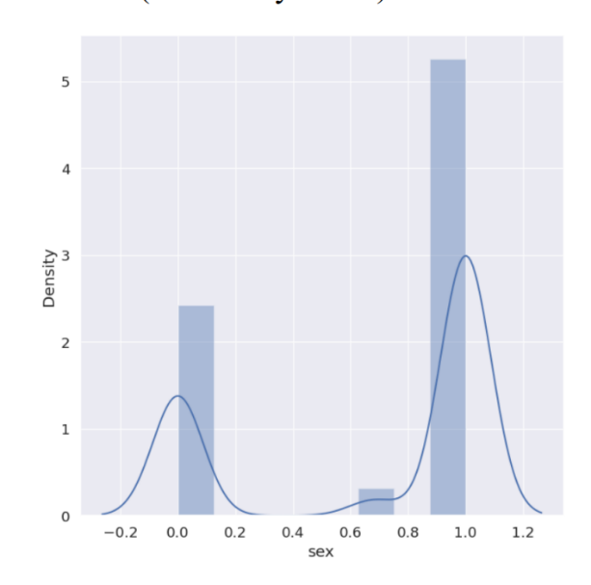

Figure:

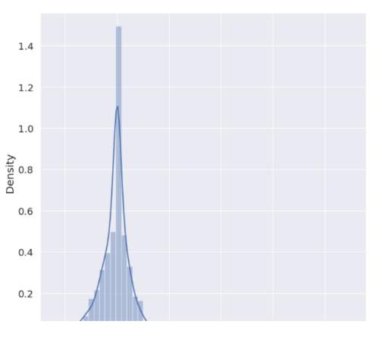

Figure:

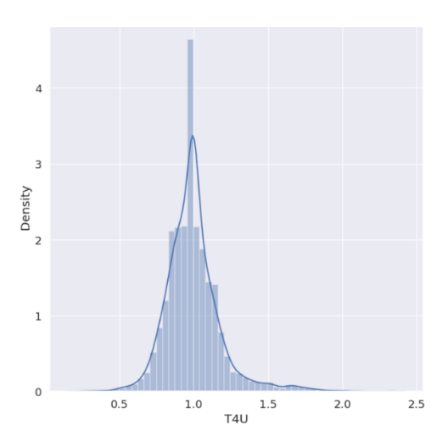

Figure:

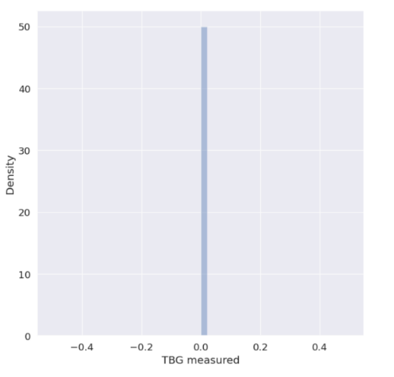

Figure:

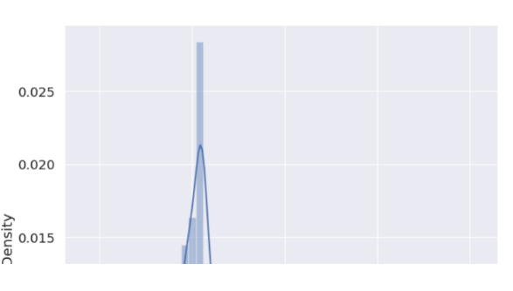

Figure:

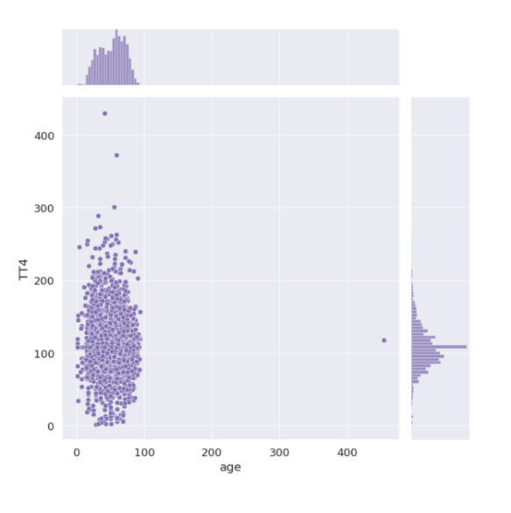

Figure:

**IV. RESULTS**

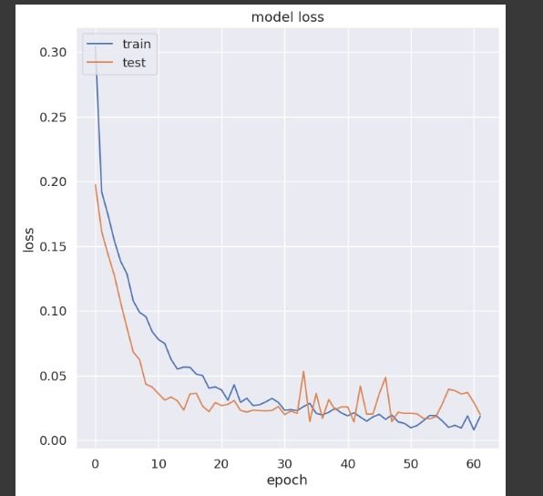

Figure:

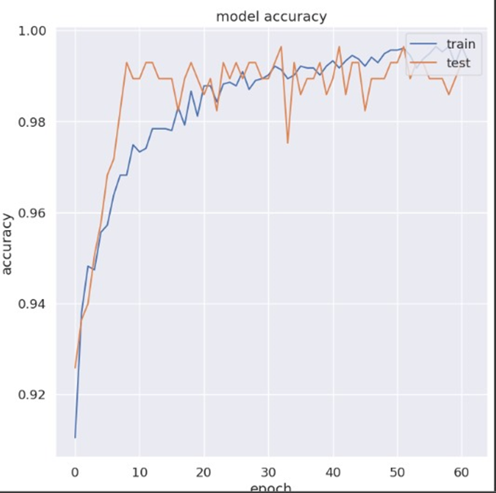

Figure:

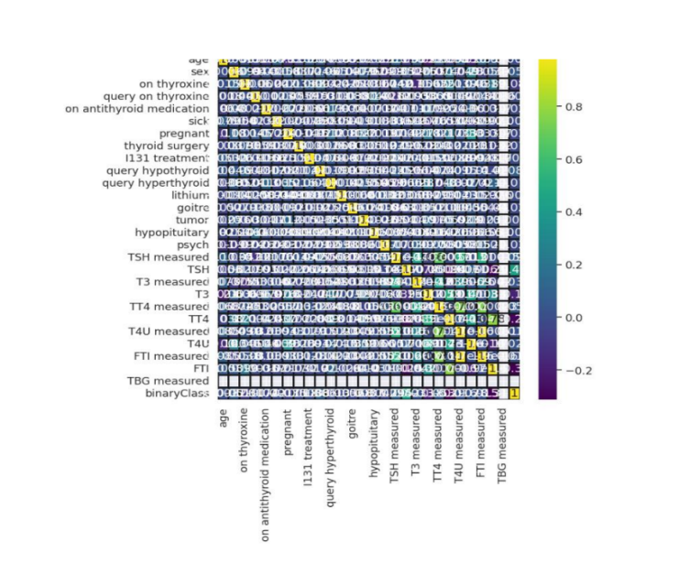

**V. CONCLUSION**

**V. DISCUSSION AND FUTURE SCOPE**

The project's emphasis on sophisticated categorization for predictive insights into thyroid health via a mobile app makes major contributions to the fields of healthcare and technology. The use of machine learning algorithms for binary classification, particularly in discriminating between normal thyroid function and anomalies, has the potential to transform thyroid health monitoring. The addition of a mobile app improves accessibility and user engagement by giving consumers with a simple platform for real-time insights into their thyroid health. The incorporation of characteristics such as T4U, TSH, and maybe other health markers improves prediction accuracy by leveraging complete data. The concept addresses the growing relevance of preventative healthcare by enabling users to proactively monitor their thyroid health and potentially spot issues early on. Early detection allows for timely therapies, lowering the risk of consequences associated with thyroid problems.

The project's future scope includes increasing the feature set for thyroid health classification, including new health markers, and potentially wearable devices for continuous monitoring. Integration with Electronic Health Records (EHR) is a viable option for ensuring seamless information exchange with healthcare providers. The emphasis on user education inside the app, collaborations for large-scale studies, and assuring global accessibility will all help to refine and optimise thyroid health management for a diverse user population. Ongoing dedication to technical breakthroughs and user-centered design is critical for long-term influence and innovation.

**VI. REFERENCES**

Chiovato, L., Magri, F., and Carlé, A. (Year). Hypothyroidism in Context: Where We Have Been and Where We Are Going.

Evered, D.C., Ormston, B.J., Smith, P.A., Hall, R., and Bird, T. (Year). Hypothyroidism is classified into many grades.

Kim, [Author Initials] and [Other Authors]. (Year). Advanced Imaging Modalities for Diagnosing Hypothyroidism: A Comparative Study.

Wiersinga, W.M. (year). Environmental Factors and the Pathogenesis of Autoimmune Thyroid Disease: A Clinical Perspective.

Vanderpump, M. P. J., Tunbridge, W. M. G., French, J. M., Appleton, D., Bates, D., Clark, F., and Williams, G. R. (Year). Thyroid problems in the community: a twenty-year follow-up to the Whickham Survey. (A longitudinal study of the prevalence of thyroid diseases in the community.)

Hollowell, J. G., Staehling, N. W., Flanders, W. D., Hannon, W. H., Gunter, E. W., Spencer, C. A., and Braverman, L. E. (Year). Serum TSH, T(4), and thyroid antibodies in the US population (1988–1994): National Health and Nutrition Examination Survey (NHANES III). (Data on TSH, T4, and thyroid antibodies in the United States.

Garber, J. R., Cobin, R. H., Gharib, H., Hennessey, J. V., Klein, I., Mechanick, J. I., and Woeber, K. A. (Year). The American Association of Clinical Endocrinologists and the American Thyroid Association have collaborated to develop clinical practice guidelines for hypothyroidism among adults. (Guidelines for clinical practice with hypothyroidism.)

Biondi, B., and Cooper, D. S. (year). The clinical implications of subclinical thyroid dysfunction. (A overview of the clinical implications of subclinical thyroid impairment.)

Jones, [Author Initials]; [Other Authors]. (Year). Nutritional Interventions and Improvements for Hypothyroid Patients: A Dietary Strategy Study. (Search for studies on the effects of nutrition on hypothyroidism.)